My tribute to Robert Andrew Blust [2022.02.19] R. David Zorc
Bob and I met at the first ICAL conference in Honolulu in January 1974. He was about to defend his dissertation, and I was a year off from doing so with mine. During those times, most activity in the Philippine and Austronesian field was data collection by dozens of graduate students or SIL linguists doing intensive research. No one seriously considered expanding the corpus of etymologies beyond those of Dempwolff (1938). Indeed, the 1950’s through the 1960’s were decades of consolidation, when scholars like Dyen or Dahl were refining or redefining Dempwolff. Laws like the RLD [*d], RGH [*R], or hamzah [*q vs *ʔ] were of greater concern than finding new etymologies. The 1970’s and 1980’s were two exciting decades which saw many dissertations or studies of Austronesian subgroups, such as Blust’s intensive research in Borneo. This era witnessed studies of a wide variety of microgroups such as Bisayan, Manobo, Bilic, Minahasan, Sangiric, all of which contributed to our growing picture of Austronesian.
Blust did have a difficult start. His dissertation never wound up getting published, and his very first Austronesian publication “Some New Proto-Austronesian Trisyllables” (1969) was not supported by later evidence. Therein he proposed 7 reconstructions that had an extra syllable based on Kelabit reflexes. His ACD has clearly rectified these. The important lesson we all can learn from this is never to project the peculiarities of a daughter language onto the highest proto-language without external supporting evidence. So, while he may not have gotten off to a great start, this was clearly rectified by over 50 subsequent years of strict, intense, and brilliant scholarship.
Bob and I had a long snail mail correspondence. My file folder is 1 inch (2.54 cm) thick and his part of my overall library is 15 inches (28.1 cm) wide covering his brief sojourn in Australia, his time in Leiden, and his many years at U/Hawaii. One thing that struck me is his constant mention of his family and how he spent time with his daughters on picnics, weekends, and overseas trips. These struck me as indicating that he was a good father and a devoted husband. I imagine we both had a difficult time balancing the requirements of research and publication with family obligations.
Every paper that I wrote and all of his that touched on Philippine topics were shared and discussed extensively between the two of us. One among many of his major contributions was the isolation of Proto-Greater-Central-Philippines (1991). After having gone through three proposals concerning the subgrouping of the Philippine languages (identity, overlap, and inclusion -- a brilliant precursor to his 2020 “Resurrection of Proto-Philippine” paper), he proposed (in the Appendix) 94 lexical innovations that establish PGCP. We must bear in mind that his overall purpose (which he mentioned to me) was to justify the inclusion of Gorontalo and Mongondow within this subgroup, and, in this, he succeeded. Time and the ACD have since shown that 38 proposed PGCP etyma were assignable to a higher level. His inclusion of Palawanic was not supported by the shared innovations presented. The fact that Bob and I worked to complement each other’s efforts is demonstrated by a recent analysis of the ZDS <https://zorc.net/RDZorc/PHILIPPINE-ETYMA/> with over 500 etymologies marked as PGCP (or GCP). Each of the Palawanic members clearly shared in the development of the Proto-Greater-Central-Philippine lexicon. So Bob’s insights have prevailed.
In February of 1992 Bob got a federal grant and honored me with a contract to be a consultant editing his ever-growing Austronesian corpus, which eventually became the ACD. He and I had dozens of snail mail exchanges about hundreds of etymologies through July of 1993. He faithfully acknowledged all such assistance within individual entries. It was during this period that I realized I could not compete with Bob in discovering Philippine or higher-level etymologies. So I decided “if you can’t lick ‘em, join ‘em” and sought to enrich the ACD as best I could. After my retirement, most of 2017 was dedicated to going through the ACD and sharing with Bob additional data to support his etyma, or fix minor typographical errors.
I was extremely pleased that Dr. Blust took a major part in championing the indication of accent on PPH etyma. It seems that once my accent proposals were published (Zorc 1972 and 1978a) and absorbed, he started indicating accent on PPH reconstructions. The ACD reveals the correct accent placement on several hundred PPH etyma.
It is difficult for us “old folks” to keep up with advances in the field. Bob tended to maintain long-outdated exonyms for languages he incorporated. His “Bikol” is more correctly Naga Bikol (Bikol being a tripartite subgroup of Philippine languages), his “Tiruray” has been revised to Teduray (although no linguistic publication has thus far rectified this), and his “Sindangan Subanon” from Reid (1971) is Central Subanen (Lobel 2013).
When I went through his LOANS section of the ACD in October 2018, I encountered a rather humorous repetition of an error introduced by Microsoft Word that managed to escape his attention. Dozens of widespread loans were attributed to “Malagasy” when it is clear from context that “Malay” was intended. These came about because after typing the first three letters “Mal”, Microsoft Word automatically supplies the remainder of a recently keyboarded entry with those same letters, which must have been “Malagasy”. Since Steve Trussel re-entered the data the Bob supplied him, he (Steve) did not catch these changes. Bob was grateful when I called these typos to his attention and they have all been corrected.
Similar to so many other scholars, I have personally benefitted from his genius. His breadth of understanding the cognates among hundreds of Austronesian languages is mind boggling. There are few Austronesianists who can feel as secure or comfortable dealing with the languages of Taiwan, the Philippines, Indonesia, Sabah, Sulawesi, Papua-New Guinea, and Oceania. Obviously there are specialists in each of these areas, but he could speak or write with authority on almost any of these at any time in the recent past.
It is not just the quadrupling of etymologies since Dempwolff that is to his credit, but the intricate semantic assignments that make him stand above and beyond all other scholars. The time he dedicated to assigning just the right meaning to each etymology in the ACD is a tribute to his brilliance, and he recorded these insights in several excellent articles: Blust (1987) on ‘house’ words, (1989) ‘semantic cycles in historical change’, (1996) semantics of PAN *-an ‘locative’, (2005) ‘liver’ and ‘lungs’: a semantic dyad, (2010)’five patterns of semantic change’, (2017) PMP *suku ‘lineage, quarter’, (2018) PMP *kamaliR ‘men’s house’, and (2022) PMP *guntiŋ ‘scissors’.
Besides the extreme value of the Cognate Sets and Finderlist sections within the ACD, his Languages section offers hundreds of etymologies in specific languages for scholars interested in developing etymological dictionaries or native speakers who might be interested in the history of a huge chunk of their vocabulary. I have benefitted from his copious treatments of etyma: 3999 in Tagalog, 3737 in Ilokano, 3011 in Cebuano, 2913 in Naga Bikol, 2111 in Maranao, 1578 in Aklanon , 1457 in Itbayaten, 1313 inHanunoo. This listing could go on and on!
All in all, I remember him fondly. I admire and wish to extol and emulate his many accomplishments. I do miss him terribly. No longer will my Inbox make my day by seeing a paper, a question, or a response from this wise and productive man.
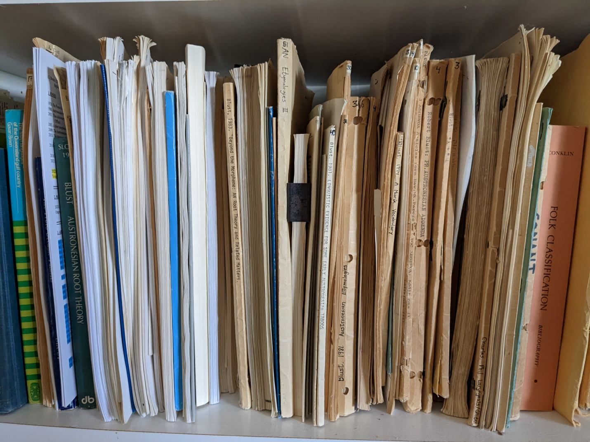
The “Blust” section of R. David Zorc’s personal library.

